Data Sheet
Touchclave-R Models

Standard Range Features  - Cylindrical chamber  - Pneumatically locked door  - In-chamber heating  - Air ballast  - 8-program touchscreen control system  - Internal data archiving for up to 5000 cycles  - Individual PIN codes for traceability  - Fully self contained  - Small foot-print | 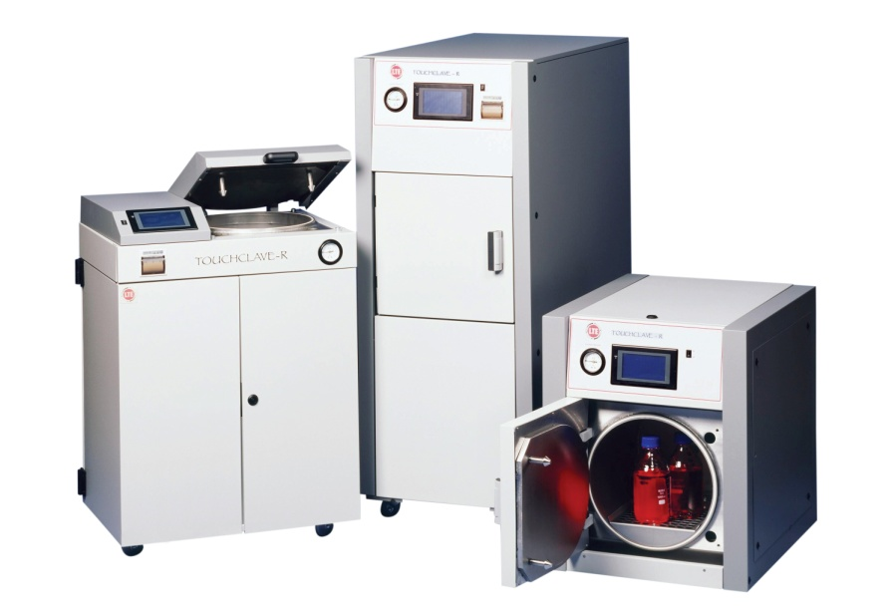

Capacity/Vessel Type | 40, 60, 120 and 160-litres, cylindrical section
Vessel Dimensions, mm | 350dia x 415/625mm D (40/60-litre models)  500dia x 610/825mm D (120/160-litre models)
Shelves/Positions | 1/1
Pressure Vessel Material | High grade 316L stainless steel
Pressure Vessel Finish | Bead blast satin finish (<2.5µm)
Pressure Vessel Compliance | PD5500:2000, EN93/27/EC
Other Applicable Standards | BS2646,
Door Type | Push-n-seal door action. Hinged
Door Seal | Floating
Steam Source | In-chamber heating
Temp. Range, ˚C | 100-137
Pressure Range | Zero to 2.62bar
Overall Dimensions, mm | See brochure for details
Weight, kg | 210
Control System | 8-program touch-screen control system
Data Archiving | Not included
Standard Cycle Features | Timed auto-start; batch no. input; operator ID
Silent Air Compressor | Included
Cooling Method | External fan plus dynamic in-chamber cooling
Other Options | Air Ballast included as standard  For other options see quotation

* See Quote for details

The above is the standard specification. Any modification/deviation for the above will be clearly identified on the quotation front sheet

Site Services
Model | TCR40 | TCR60 | TCR120 | TCR160
Capacity | 40 litres | 60 litres | 120 litres | 160 litres
Electrical Requirements (Standard Models) | Electrically Heated  1-phase, 220-240V, 50Hz, 13A  Commando Plug – See Electrical Termination | Electrically Heated  1-phase, 220-240V 50Hz,  25A (TCR60H)  20A (TCR60V)  Commando Plug – See Electrical Termination | Electrically Heated  1-phase, 220-240V 50Hz,  32A (TCR120H)  32A (TCR120V)  Commando Plug – See Electrical Termination | Electrically Heated  1-phase, 220-240V 50Hz,  32A (TCR160H)  32A (TCR160V)  Commando Plug – See Electrical Termination
Electrical Requirements (Boosted Heater Models) | Electrically Heated  1-phase, 220-240V, 50Hz, 20A  Commando Plug – See Electrical Termination | Electrically Heated  1-phase, 220-240V 50Hz,  32A (TCR60H)  30A (TCR60V)  Commando Plug – See Electrical Termination | Electrically Heated  3-phase, 380-440V N+E, 50Hz,  20A/Ph (TCR120H)  20A/Ph (TCR120V)  Commando Plug – See Electrical Termination | Electrically Heated  3-phase, 380-440V N+E, 50Hz,  20A/Ph (TCR160H)  20A/Ph (TCR160V)  Commando Plug – See Electrical Termination
Water Supply | Manual fill with potable water.  Alternatively for models with Automatic Water-Fill Option:  Potable water supply with 15mm inlet. 2 bar dynamic pressure.  WATER MUST NOT BE DEMINERALISED OR DEIONISED unless the autoclave has been specifically modified for this
Drain Requirements | Can be drained into condensate container if no drain available.  Otherwise, floor/low level drain, min 50mm dia.  Continuous untrapped fall from autoclave to drain required.  Waste autoclaves should have sealed and vented drains in line with the recommendations of BS2646 Part 2 1990  Drain must be capable of withstanding high temperatures in excess of 100ºC (or 70ºC if a condensate unit is fitted).  For multiple unit installations, the above applies to EACH autoclave. If a common drain is to be used, it must be of such size to prevent cross-flow from one autoclave to the other.  When in doubt, BS2646, Part 2 1990 applies.
General
Position of Services | Within 2m of rear of Autoclave and in sight
Delivery and Site Positioning | Deliveries will be ‘one-man’ unless stated otherwise in our quotation.  Unless specifically quoted, we will require a level access route into the building and to final position, suitable for manoeuvring the autoclave on its castors or on a pallet truck. Specialist lifting gear and protection to the fabric of the building is the responsibility of others.
Safety Vents | All vents point downwards at floor level. These can be exhausted outside at extra cost
Ventilation | Autoclaves must be sited in a well ventilated area
Service Access | BS2646 states that 1000mm is required around the autoclave for service. We realise this may be impractical, however, a minimum of 500mm is required at the sides and rear for servicing of the autoclave. Should this not be available, you must contact LTE to discuss other options.
Electrical Termination | The incoming electrical supply must be terminated in a suitable fused isolator. As standard, final connection of Commando Socket, Autoclave will be fitted with Commando Plug. Options for hard-wired into isolator is available with discussion.
Water Hardness | It is the customers responsibility to advise us of any hard water issues. Hardness levels should be below 50ppm CaCO₃. Operating the autoclave above this level without suitable water softeners will affect the autoclaves performance and invalidate your warranty.
Suitability of Services | LTE sales and technical staff are always on hand to provide assistance with assessing site conditions, however ultimately it is the customers responsibility to ascertain the suitability of services on site.
Continuity | It is assumed that once our engineer attends site, all services will be available and that installation can take place without delays. Extra charges will be incurred for delays outside LTE control.

